Using Venture Valley in the Classroom

Introduction
Looking for a way to engage students and teach entrepreneurial concepts? Look no further than Venture Valley from The Singleton Foundation for Financial Literacy and Entrepreneurship, a non-profit foundation focused on improving financial competence and promoting entrepreneurship.

Through Venture Valley, students learn key entrepreneurial skills and concepts through trial and error in a risk-free environment. In the free-to-play game, players have the opportunity to take on the role of an entrepreneur, pitting their business savvy against that of others. As students build their ventures and fight off rivals, they learn real business and marketing skills and experience the highs and lows of being their own boss. They can immediately see the impact of their choices as they learn to price products effectively, offer compelling services, maintain happy customers, and pay their employees well. On the quest to grow their enterprises, players engage in competitive strategic duels with boost and adversity cards, adding fast-dealing esports-type play.

Sample Uses
There are many ways Venture Valley can be used in educational settings.

Independent Assignment: Use the game as a springboard for a lesson or discussion. Allow time for students to play the game in class or assign it as homework.

Full Group Play: Project a single device and challenge students to take turns demonstrating their game-playing skills at the controls.

In-Class or After-School Competition: Challenge students to play individually, in pairs, or in small groups as part of a class period, enrichment opportunity, or afterschool program. Recognize students who reach specific in-game goals.

Community Night: Invite students and their parents to play the game in an entrepreneurship-themed evening or weekend program. Extend invitations to local business owners to talk about their real-world entrepreneurial challenges and successes.

Educational Resources
Discover Venture Valley offers a suite of resources where students learn business concepts and life skills. Developed through a partnership between the Singleton Foundation and the nationally-recognized education-content creators at Discovery Education, Discover Venture Valley provides ready-to-use resources, including classroom activities, videos, and more. Materials align to educational standards across multiple disciplines, including English language arts, math, business, and financial literacy. Sample topics include:

Account types | Cost of goods | Investment | Price setting
Bankruptcy | Customer base | Market share | Revenue
Budgeting | Dividends | Net worth | Selling a business
Business loans | Gross/net profits | Overhead | Startup costs
Business valuation | Insurance | P&L statements | Wage setting

See the Venture Valley glossary for additional terms introduced and/or used in in the game.

What to Expect in Venture Valley
Venture Valley is a fast-paced mobile and PC business-strategy game where players take on the role of an entrepreneur, pitting their business savvy against that of others. The game, which is completely free and has no in-app purchases or ads, features both competitive esports-style multiplayer play and a single-player campaign with 35 unique missions.
Students can select from one of two game modes.
Solo Mode: Students complete business-building challenges by fending off adversity and taking part in corporate challenges.
Multiplayer Mode: Students can play with classmates in custom lobbies or be matched with other active, online players.
No matter the mode, all entrepreneurs start Venture Valley with a simple dog-walking business in Fortune Springs. As the game unfolds, students seek to achieve business goals or “missions”, unlock access to 16 businesses, and experience three additional game maps -- Mapleburgs, Brickyard, and ultimately The Palms.

Mentors pause the game to introduce key entrepreneurship concepts, offer advice, and provide business objectives. Students apply this information as they face decisions throughout the game, including determining prices, setting employee wages, and deciding how to use their profits. As they progress, students can move money into personal investment accounts, reinvest their profits into established business, or expand their empire by acquiring or building additional businesses. Cash-strapped students can also take out loans to fund business purchases.

Game strategy comes into play as students customize their deck of “Boost” and “Adversity” cards. These cards can be played benefit their own business or slow the progress of opponents. Students understanding of business concepts such as marketing, cost of goods and services (COGS), labor strikes, and more leads to more effective use the cards.

Intensity is high in match-based competitions as players need to make quick, tactical decisions to achieve goals, while multitasking between several businesses and reacting to in-game events. Throughout, the goal remains the same: earn the most profits and top the leaderboard.

Game tips and a downloadable “How to Play” pdf are available at https://venturevalleygame.com/how-to-play/.

Accessing the Game
Venture Valley is available on multiple platforms and devices.
iPhone and iPad: Download the game from Apple’s App Store.
Android devices: Get the game on Google Play.
PC and Mac: Install Steam and then download the game.

How to Set Up Steam and Install Venture Valley
To play Venture Valley on a PC or Mac, you will need to access it through Steam. If you don’t have Steam on your device(s), the following are one-time instructions for setting up Steam. If you have the necessary administrative rights to the device, you can follow these directions to get Steam and Venture Valley set up on your devices. If not, provide these instructions to your technology team for approval and installation

1. Open a web browser and go to https://store.steampowered.com.

2. In the top-right corner of the screen, click the green button that says "Install Steam."

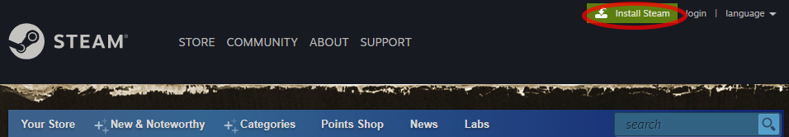

3. After clicking "Install Steam," you'll be taken to a new page, where you can download Steam. Click "Install Steam" and a file named "SteamSetup.exe" or "steam.dmg" (depending on whether you're using a PC or Mac) will begin downloading.

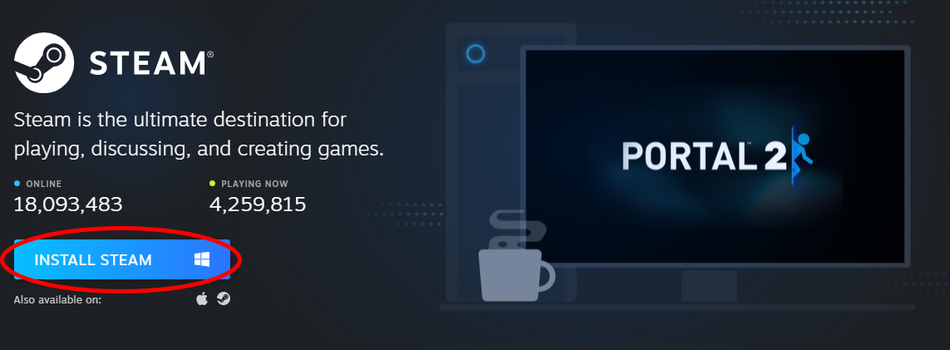

4. Once Steam has finished downloading, click on the file and it will launch the Steam Setup app. Select "Next," and choose the language you want Steam to use along with where you want Steam’s files to be located.

5. After installing Steam, click finish. Steam will open. Locate the search bar in the top right corner and enter Venture Valley. Click on the game once it appears to be taken to the Venture Valley store page.

7. After selecting Venture Valley you will be taken to the Store Page.

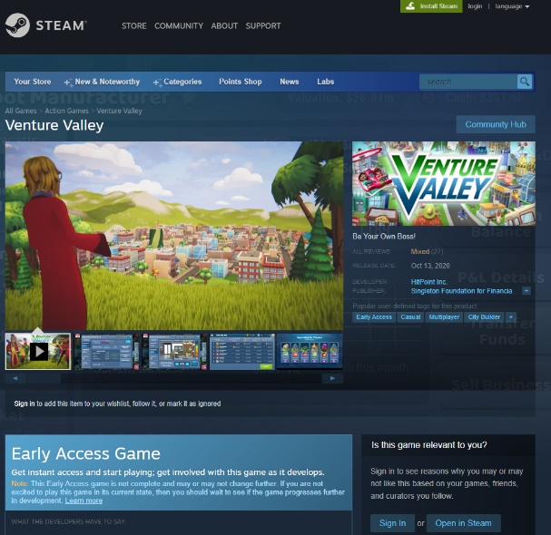

8. On the store page, scroll down until you see the green “Play Game” button. Select it to install Venture Valley. After installing Venture Valley, you will be able to open and play the game.

Venture Valley FAQs
What is Venture Valley?
The free-to-play Venture Valley game is a fast-paced multiplayer mobile and PC business strategy game where players take on the role of an entrepreneur, pitting their business savvy against that of others. As entrepreneurs build their ventures and fend off rivals, they learn real business and market skills and experience the highs and lows of being their own boss. On the quest to grow their enterprises, players engage in competitive strategic matches with boost and adversity cards, adding fast-dealing esports-type play.

Who developed the game?
The Singleton Foundation for Financial Literacy and Entrepreneurship, in conjunction with contracted game development teams, produced the Venture Valley game. The foundation is a nonprofit with the mission of making financial competence fun and engaging for everyone by using the power of entertainment to capture attention, create change, promote entrepreneurship, and to inspire individual achievement.

Is the Venture Valley completely free?
The game is free and has no in-app purchases. There are also no ads in Venture Valley.

What platforms is the game available on and what are the system requirements?
Venture Valley is on mobile (iOS and Android via the App Stores) and PC (via Steam). Game play is online. There is no offline version of the game. For optimal play, players should have:
- Android Minimum required OS: 5.x.x
- iOS Minimum required OS: 11.x
- Windows Minimum required OS: Windows 10
- Mac Minimum required OS: High Sierra 10.3.6

What is the mission of the game?
The mission in the game is to learn how to successfully grow simple businesses (like dog walking), and master increasingly more sophisticated enterprises (like a robot factory)... all while beating the competition and being mentored by entertaining Venture League mentor entrepreneurs.

What kind of game is Venture Valley?
Venture Valley is a fast-paced, multiplayer mobile and PC business strategy game where players take on the role of an entrepreneur, pitting their business savvy against that of others. As they build their ventures and fight off rivals, they learn real business and market skills and experience the highs and lows of being their own boss. On the quest to grow their enterprises, these entrepreneurs engage in competitive strategic duels with boost and adversity cards, adding fast-dealing esports-type play. Players go against both AI or real-world competitors to prove their skills and business prowess. They can play in multiplayer maps against friends by completing challenges for each game map.

What are the objectives in the game?
A player has won when they have won all the contests for all the businesses and beaten all the Venture League members to become a member of the Venture League. However, players can always continue to play custom matches or sponsored tournaments without limits.

How do I set up students to play against one another in multiplayer mode?
Using the Custom Game Lobby mode, students can set up private matches with classmates. All businesses and events that are required for specific maps are available. Students can dive in and help each other or navigate the game on their own. These games will be stand-alone walled events.

Will students lose their progress if they switch from one device to another?
Students must register an account to play with different platforms. Once this is done, their progress will be retained across platforms.

How do you win in the game?
Winning and success takes multiple forms.
- Player progression -Players earn experience, higher player levels, skill points, money as they complete challenges that allow the player to grow their business portfolio and advance through the game unlocking new maps and multiplayer maps.
- Winning matches - The first player to complete all the match goals, such as walk 1500 dogs, earn 10K in revenue, to be crowned the winner. Players who gain a top three finish on the match leaderboard get higher awards. Placing number one for a match goal earns the most and being the first player to complete all match goal earns the player bonus awards.

How do I or my students join a tournament?
At the beginning of the tournament, you will receive a special 4 digit code that you must enter from the Multiplayer screen. This will get you into the tournament.

How do I or my students get help in the game?
In the game, go to Venture Tower and check out the Tips & Tricks information located there. Still stuck? Please email Support@VentureValleyGame.com for product or customer Support. For all other inquiries, please email Community@VentureValleyGame.com

How long does it take to ‘win’ the game or build a successful business in the game?
Players can set up successful business within minutes. The first player to complete all match goals wins the match—and the match ends at that moment. If no player wins all the match goals time runs out on the match.
- Mapleburgs matches are no longer that 15 minutes.
- Brickyard matches are no longer that 30 minutes.
- The Palms matches are no longer that 40 minutes.

Does Venture Valley collect and/or sell my or my student’s data?
No! Venture Valley does not collect and/or sell player data.

Can I talk about or post videos of Venture Valley on social media?
Yes, please share Venture Valley with your students, colleagues, and friends.

